Hazard Communication
The Name of Company (Company) Hazard Communication Program provides information to employees about use, handling and storage of hazardous chemicals. The full Hazard Communication written program is available from the Company. This document summarizes the Company’s Hazard Communication program.
Employees have the right:
- To know how to identify potentially hazardous chemicals that they may encounter in the workplace;
- To know the particular health and safety hazards associated with these chemicals
- To know how to protect themselves from the effects of these chemicals.
- For employee’s physician and collective bargaining agent to receive information regarding hazardous chemicals to which an employee may be exposed
- To not be discharged or receive other disciplinary action due to exercise of employee’s rights under the Hazard Communication law.

Employee should recognize and understand potential hazards based on:
  - Labels on containers
  - Information provided in new SDS (Safety Data Sheet) format
Labels on Containers:
Here is what a uniform label looks like:
- Product Identification (i.e., name of product, unique means of identification)
- Supplier/Manufacturer identification: Name, Address, Telephone number
- Precautionary Statements are related to prevention, response, storage and disposal. ( i.e. “wear respiratory protection” and/or “wash with soap and water” and/or “store in well ventilated place.”)
- Standardized symbols called “Pictograms” (see below) Note: more than one pictogram may be included, as appropriate.
- Signal Words: there are only two possible words. (Note: Not all labels will have a signal word as some chemicals do not require a signal word)
  - Danger: more severe hazard
  - Warning: less severe hazard
- Hazard Statements are specific statements of warning regarding the chemical such as “Flammable liquid and vapor” and/or or “Causes skin irritation” and/or “May cause cancer.”

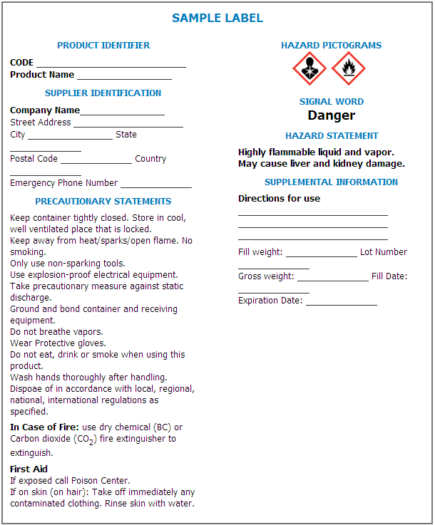
Labels on Containers - There are 9 standard Pictograms used globally that cover 30 specific Health Hazards, Physical Hazards and OSHA Hazard Classifications.
Health Hazards
Irritant (skin and eyes)
Skin sensitizer
Acute toxicity (harmful)
Narcotic effects
Respiratory tract irritant
Hazardous to ozone layer
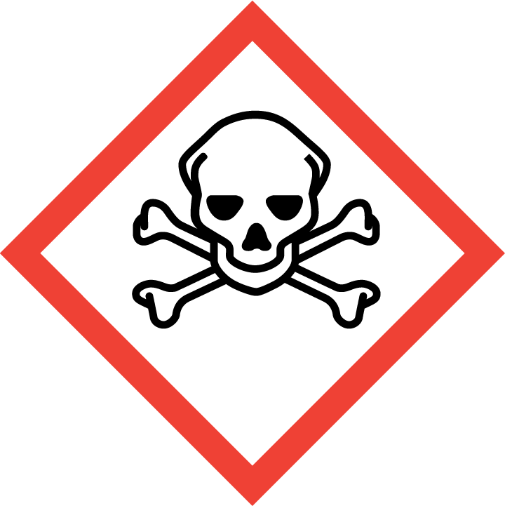
Acute Toxicity (fatal or toxic)
Carcinogen
Respiratory sensitizer
Reproductive toxicity
Target organ toxicity
Mutagenicity
Aspiration Toxicity
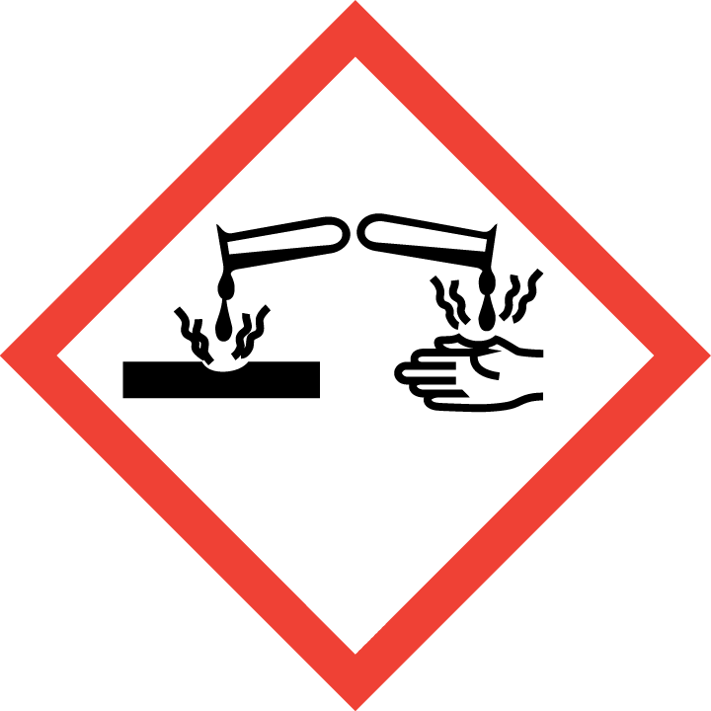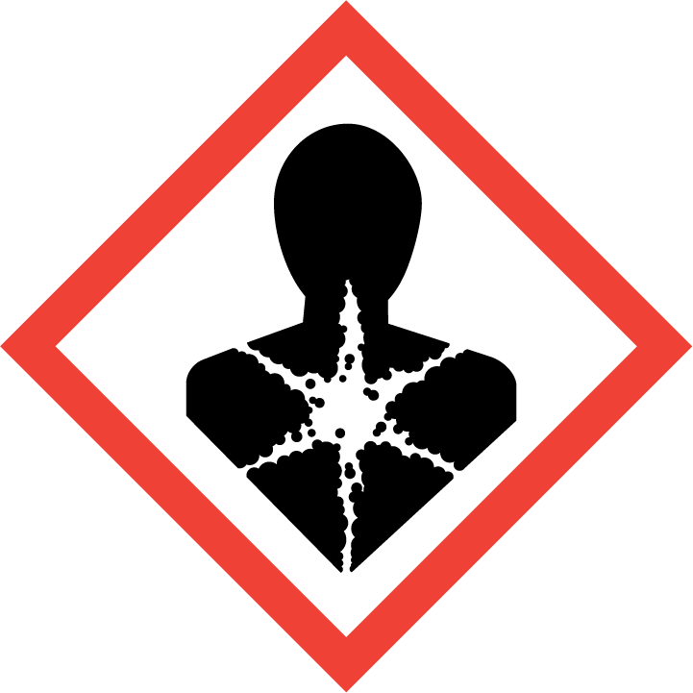
Skin corrosion/Burns
Eye Damage
Corrosive to metals (also a physical hazard)
Physical Hazards
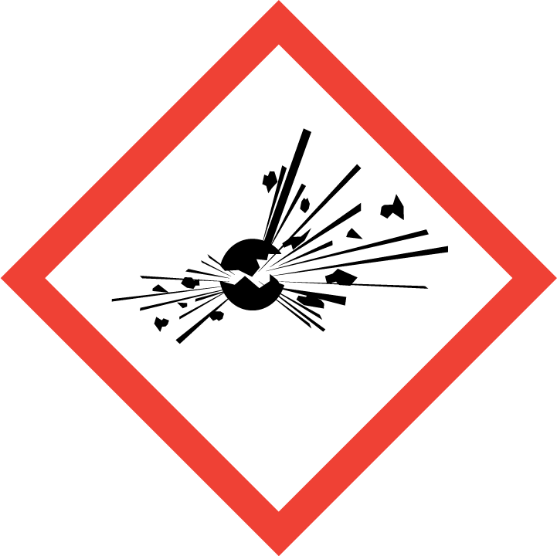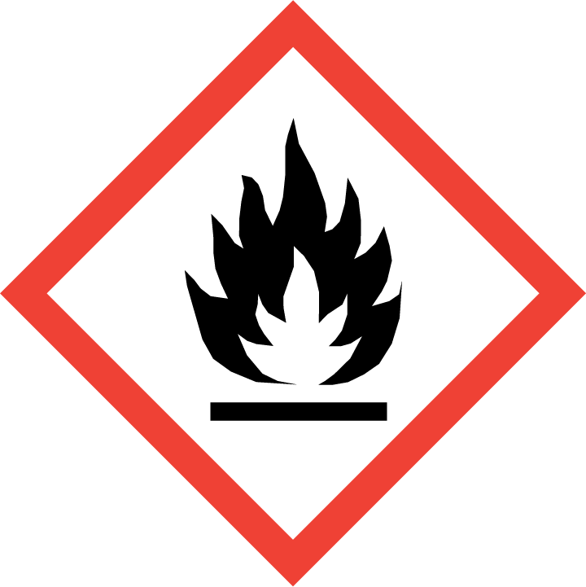
Flammables
Self -reatives
Pyrophorics
Self-heating
Emits flammable gas
Organic peroxides
Explosives
Self-reactives
Organic Peroxides

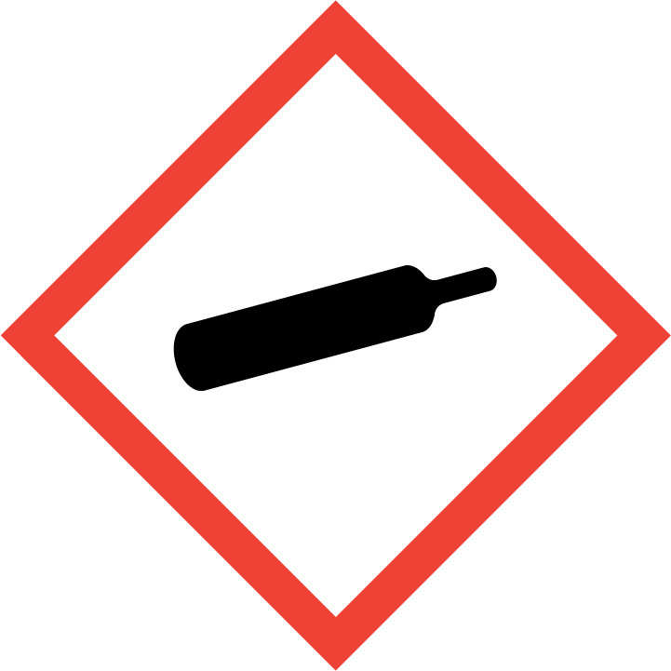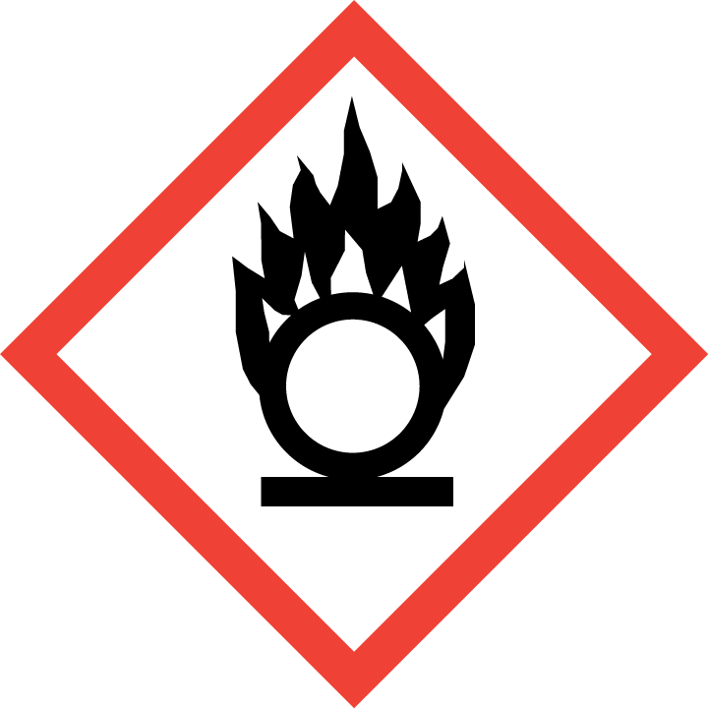
Oxidizers
Gases under Pressure
Environment
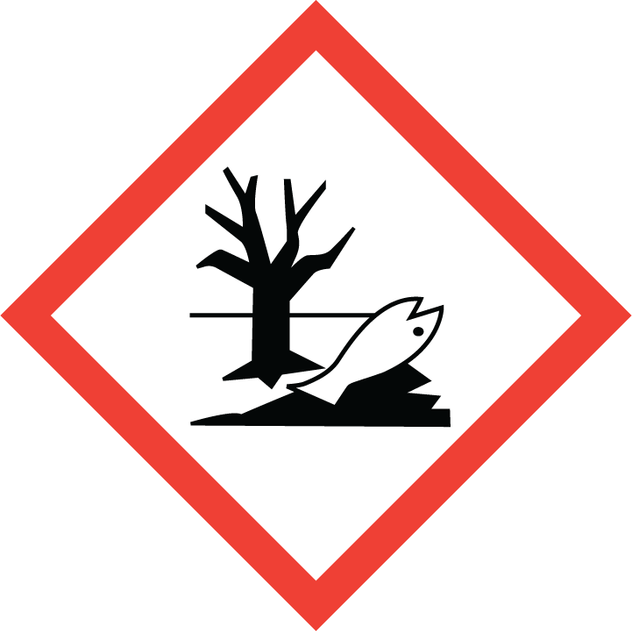
Aquatic Toxicity

Safety Data Sheets (SDS)
Under revised new Hazard Communication standard, Material Safety Data Sheets (MSDS) are being replaced by Safety Data Sheets (SDS). All SDS will have a consistent 16-section format. Each manufacturer or distributor of a chemical provides information about a chemical’s hazards on Safety Data Sheet (SDS). Note that there is a phase in period, until June 2014, when either the old MSDS or SDS may be used.
SDS are available to all production employees working a show being produced for Viacom through the Viacom/Paramount SDS database maintained by the 3E Company:

www.3Eonline.com
Section 1 – Identification – identifies chemical and recommended uses. Contact information for manufacturer/ supplier.
Section 2 – Hazard(s) identification - information associated with each identified hazard.
Section 3 – Composition -Information on Ingredients- impurities and stabilizing additives
Section 4 – First-aid Measures – initial care before emergency personnel arrive.
Section 5 – Fire-fighting -Measures in case of fire involving the chemical
Section 6 – Accidental Release Measures- How to contain/clean up to spills, leaks, releases.
Section 7 – Handling and Storage guidance.
Section 8 – Exposure Controls /Personal Protection- Personal Protective measures to minimize exposure.
Section 9 – Physical and Chemical Properties
Section 10 – Stability and Reactivity
Section 11 – Toxicological Information – Potential health effects, if exposed
Section 12 – Ecological Information – Potential impacts on physical environment
Section 13 – Disposal Consideration – Safe handling/disposal information.
Section 14 – Transport Information- Any special requirements for transporting the chemical
Section 15 – Regulatory Information – Any regulations applicable to the specific product.
Section 16 – Other information including date the SDS was prepared or revised.
Username = paramount
Password = msds123 or 800-451-8346

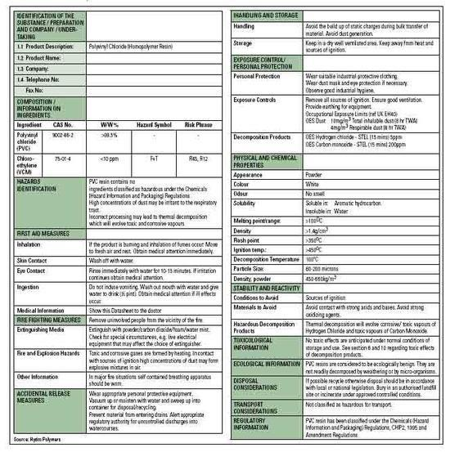

For more information about Hazard Communication, labels or SDSs, please contact Who at Company at

